C:\Users\BCharnley.BROCKSW872\AppData\Local\Temp\Temporary Internet Files\Content.IE5\CMMH5T0B\MC900371064[1].wmfC:\Users\BCharnley.BROCKSW872\AppData\Local\Temp\Temporary Internet Files\Content.IE5\0MN9JPN9\MC900358813[2].wmf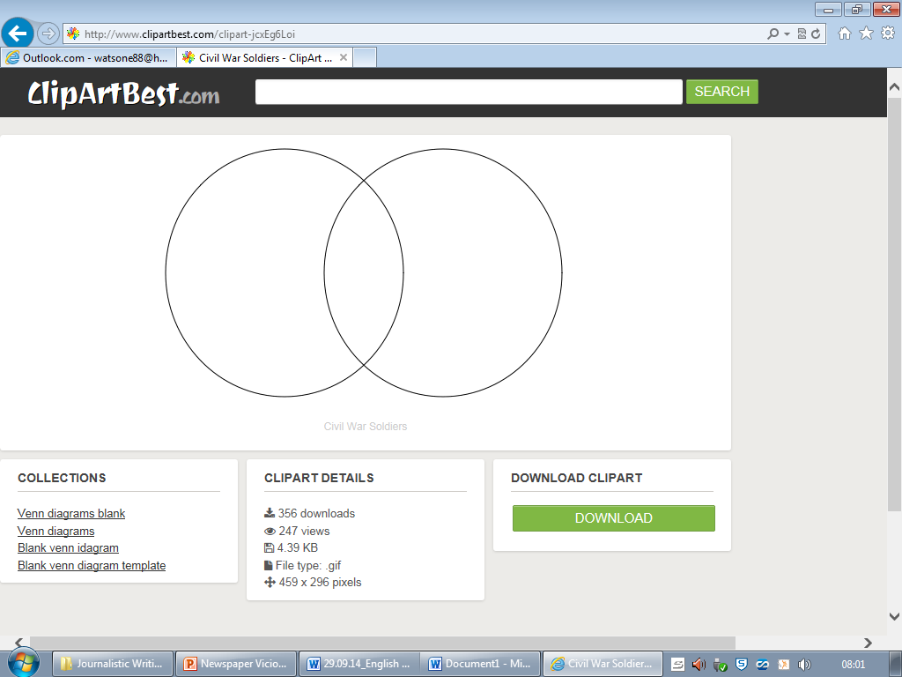

Current News Article

“Vikings Vade In”

**Venn Diagrams**

Write the features you find on the correct places in the Venn diagram.